Property Manager

1. Entities and their relationships:

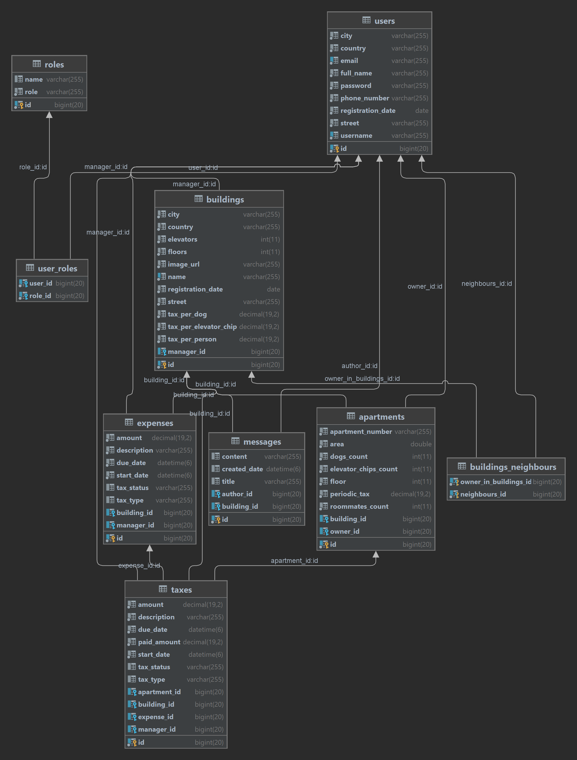

1. Permissions and functionalities by ROLE of user:

* USER:
* Edit Profile
* Change password
* View Dashboard of buildings in which he has an apartment/property
* Write messages, which can be seen by all the neighbours of the building
* View expenses of the building – paid or unpaid, description, start/due date and etc.
* View his own taxes with an option to pay the full amount or a part of it
* View his neighbours – users, who have an apartment/property in the building
* USER (MANAGER IN BUILDING) bonus rights in the building’s menus in which he is a manager:

- View ‘Edit Building’ page in which he can add or edit apartments and change taxes per person, dog, or elevator chip

- View Dashboard – same as a neighbour

- View expenses – view all expenses of the building

- Add new expense - split the full amount of expense on the selected apartments from the apartments in the building

- Change status of expense to PAID

- Delete expense – only if all taxes created by adding this expense are UNPAID!

- View taxes – view taxes of every neighbour in the building with an option to pay the full amount or a part of it

- View neighbours – view information about the neighbours with a link to their taxes

- Write messages as manager of the building, which can be seen by all the neighbours of the building

* ADMIN :
* Admin have the same rights as neighbours and managers in EVERY BUILDING
* Can create building and set the house manager for this building
* Can edit buildings information and change house manager
* View all registered users, change their personal information and change their ROLE